Question: Using difference formula, consider the table below and find out f(5).

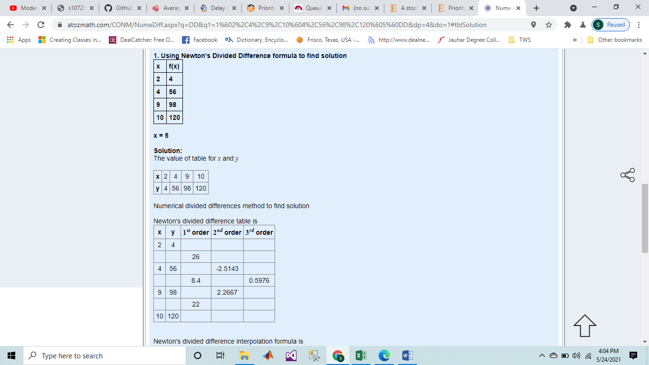

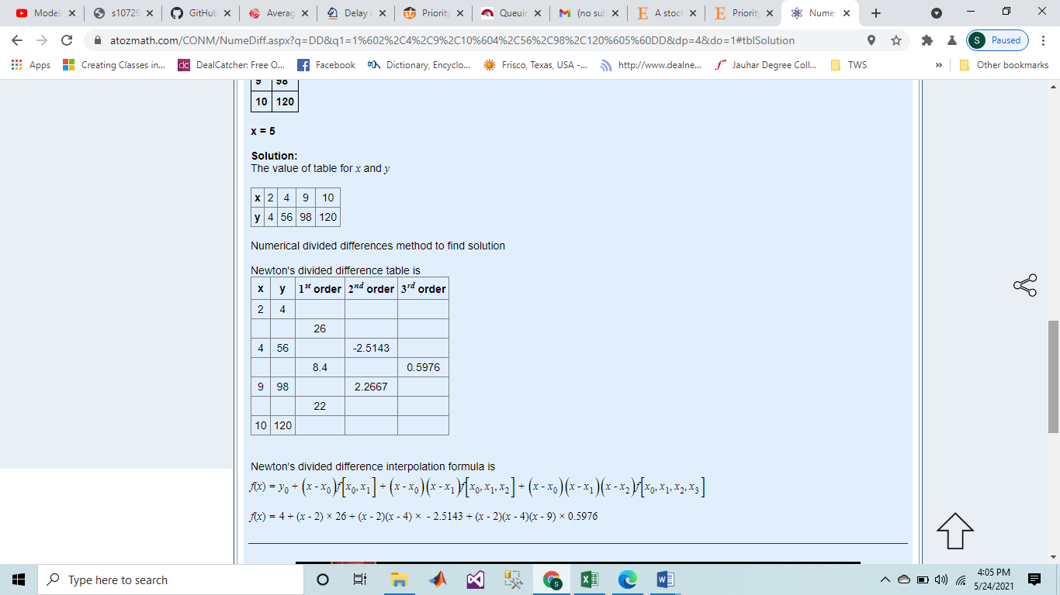

F(5) = 4 + 26(5-2)+(-2.5143)(5-2)(5-4) + 0.5976(5-2)(5-4)(5-9)

F(5) = 67.2859 [ans]